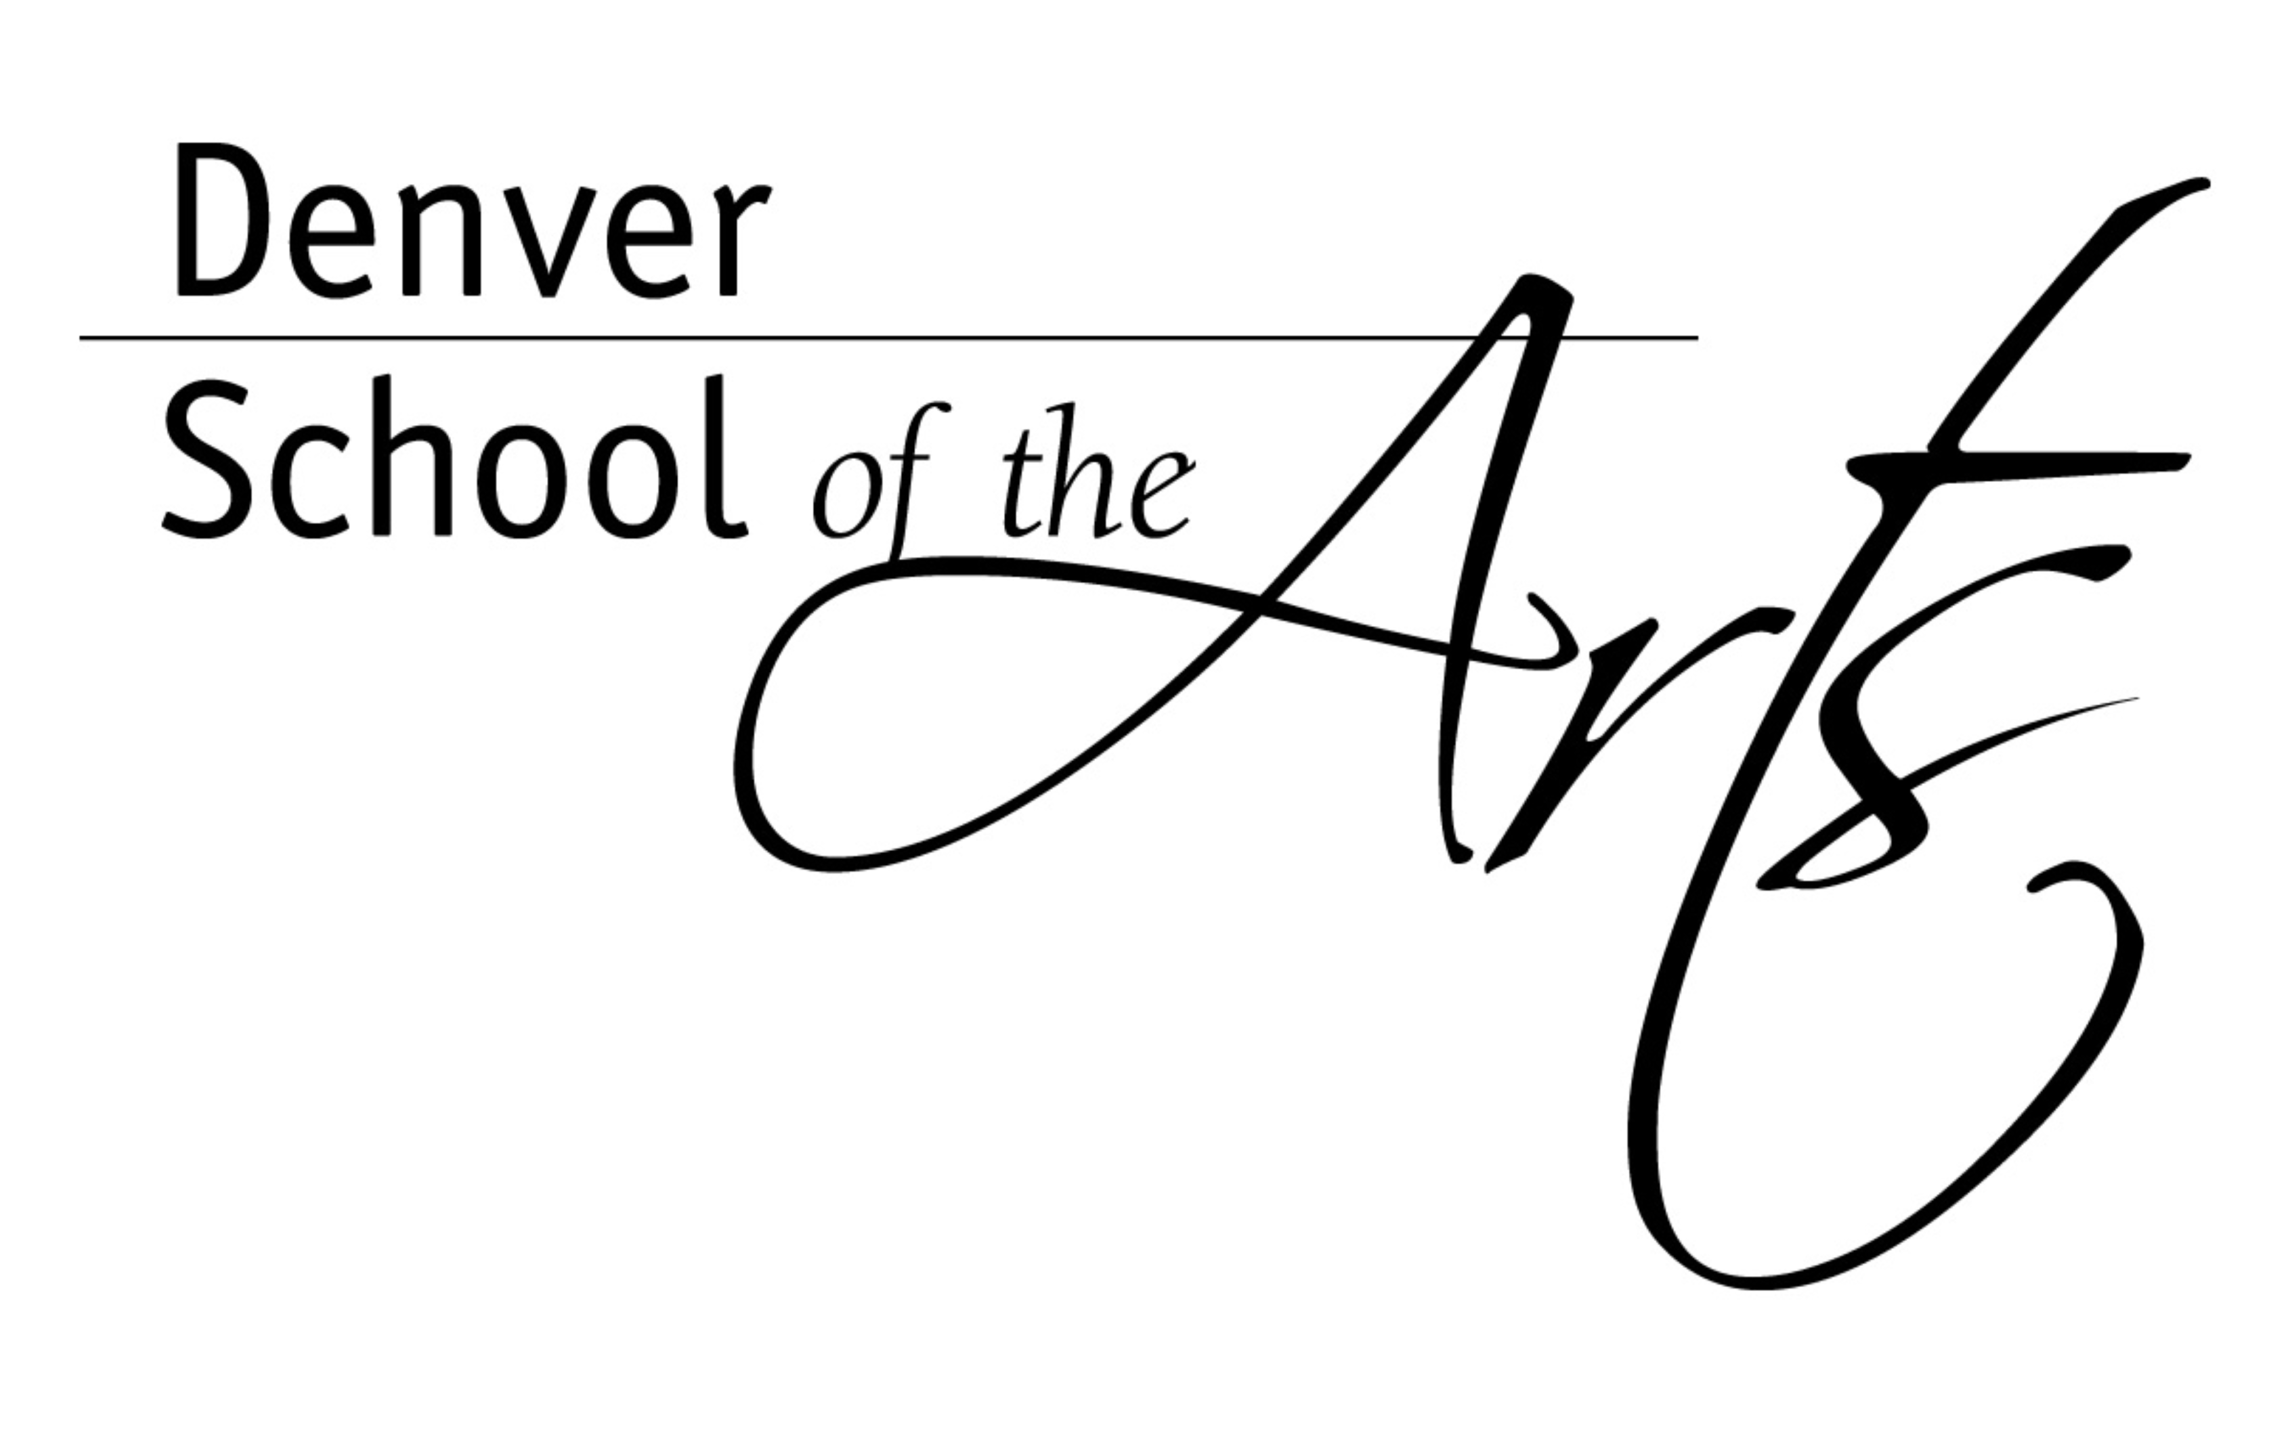

DENVER PUBLIC SCHOOLS
Office of the Principal

Phone(720) 424-1700
Fax(720) 424-1845
http://dsa.dpsk12.org
7111 MONTVIEW BLVD
DENVER, COLORADO 80220

DSA Families,

It is hard to believe that fall is upon us. Important in the month of October is the close of our first grading period and Parent-Teacher Conferences. First quarter grades will be posted in IC by October 27, 2014. These conferences are an opportunity to review your child’s progress, both academically and socially prior to the posting of grades. These conferences also allow you to have time to check in on classes in which your child might be struggling or showing frustration with.

Because of the limited time on our school calendar to conduct conferences, we must limit the amount of conference slots teachers have available. This year, teachers will have a total of sixty six (66) 10-minute slots spread between the two days of scheduled conferences. In order to accommodate as many conference opportunities as possible, we are allocating a total of four (4) 10-minute slots to families who decide to register through our online system. This means that families need to prioritize their conferences with teachers that they really want to see due to concerns either in their child’s academic classes or the arts major. Conferences are scheduled through an on-line system on a first come, first serve basis. Again, we ask that you understand that we can only accommodate 66 conferences per teacher. This amounts to about 44% of a teacher’s caseload of students.

DSA uses an on-line appointment software called SchoolAppoinments.com. Parents will be sent the link to this web page that allows for you to create an account and then sign up for 10-minute conference slots for October 20th and 21st. Parents will be able to schedule conferences starting on October 10th at 12:00 p.m. Parents will have until October 17th at 12:00 noon to finalize any conference times.

Below is the schedule for parent-teacher conferences for October 20th and 21st with respect to 10-minute slots:

Teacher conferences on October 20th and October 21st are from 1:30 to 7:30 p.m. except for the following times for a dinner break:
- 5:00 – 5:30 for teachers in 6th, 7th, 8th, VA, VCA, Stage, and Dance
- 5:30 – 6:00 for teachers in 9th, 10th, 11th, 12th, CW, Theatre, World Languages and Music

The link for parents to sign up for conferences is http://dsa.schoolappointments.com
This information and instructions will also be posted on our school’s website.

I sincerely hope that you are able to schedule and attend conferences with your child’s teachers. At DSA we strongly believe that good school relationships and collaboration allow a child to thrive and succeed.

In closing, I want to remind all DSA families that DSA students only will not have classes on Friday, October 24, 2014 while we host the national Arts Schools Network Conference at Denver School of the Arts.

Sincerely,
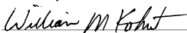
William M. Kohut,
Principal, Denver School of the Arts
Treasurer, Arts Schools Network Board of Directors

