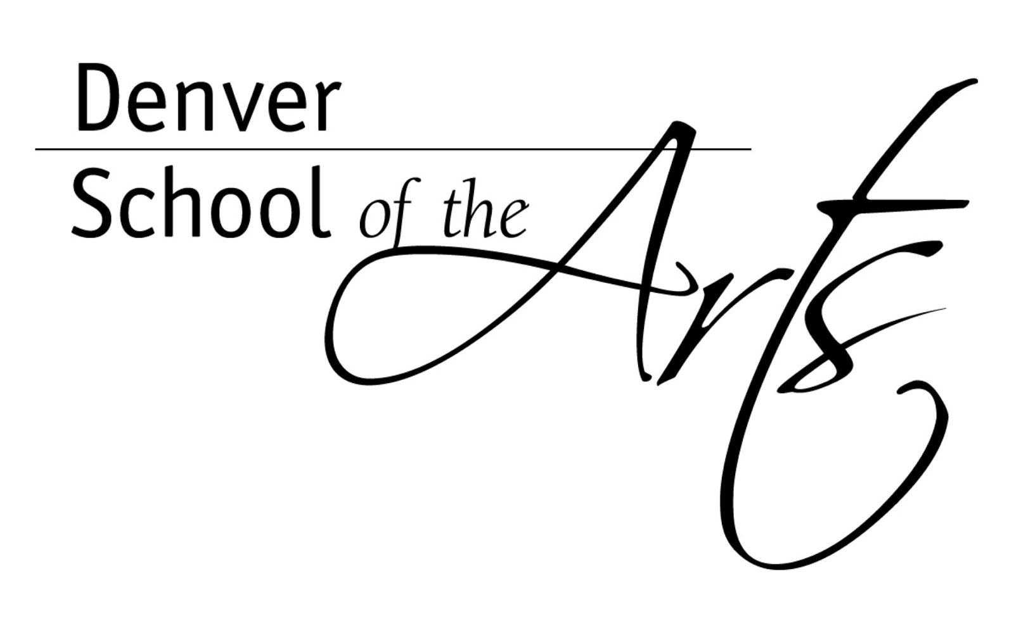
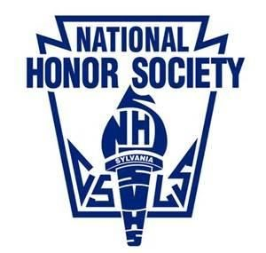
National Honor Society

Denver School of the Arts
7111 Montview Blvd ​● Denv​ er, Colorado 80220
T​elephone: 720.424-1700 ​● F​ ax: 720.424.1845

Chapter Bylaws of the
Denver School of the Arts Chapter of the National Honor Society
Adopted: September 2017

ARTICLE I: NAME

The name of this chapter shall be the Denver School of the Arts Chapter of the National Honor Society.

ARTICLE II: PURPOSE

The purpose of this chapter shall be to create an enthusiasm for scholarship, to stimulate a desire to render service, to promote worthy leadership, and to encourage the development of character in students of Denver School of the Arts.

ARTICLE III: POWERS

Section 1: This chapter operates under the direction of and in full compliance with the National Constitution of NHS. See www.nhs.us/constitutions​ . In addition, this chapter will maintain active​ affiliation with the national organization on an annual basis.

Section 2: This chapter will remain an active member of the state association, by paying annual dues and participating in state functions when possible.

Section 2. The chapter adviser(s) are given the authority to supervise the administration of chapter activities as delegated by the school principal.

Section 3: Final authority on all activities and decisions of the chapter resides with the school principal. [For reference, see Article V, Section 1 of the National Constitution.]

Section 4: Non-discrimination. Our chapter of NHS maintains policies and practices that are designed to prevent discrimination against any qualified candidate or member on the basis of race, color, religion, ancestry, national origin, sex (gender), and disability. This policy of nondiscrimination applies to all practices, including the chapter administration and the selection, discipline, and dismissal of members.

ARTICLE IV: MEMBERSHIP

Section 1. Membership in this chapter is an honor bestowed upon deserving students by the faculty and shall be based on the criteria of Scholarship, Service, Leadership, and Character.

Section 2. Membership in this chapter shall be known as active, honorary, and graduate. The faculty council shall reserve the right to award honorary membership to school officials, principals, teachers, NHS advisers, adults, students with disabilities, or foreign exchange students in recognition of achievement of outstanding service rendered to the school in keeping with the purposes of the National Honor Society. Active members become graduate members at graduation. Graduate and honorary members have no voice or vote in chapter affairs.

Section 3. Eligibility
- Candidates eligible for selection to this chapter must be members of the junior or senior class
- To be eligible for selection to membership in this chapter, the candidate must have been enrolled a minimum of one semester at Denver School of the Arts.
- Candidates eligible for election to the chapter shall have a minimum cumulative unweighted grade point average of 3.75 or weighted grade point average of 4.8.
- Students selected for National Honor Society will be given a contract at the first mandatory meeting, and must complete and turn in the contract by the specified due date to be eligible to be part of National Honor Society.

ARTICLE V: SELECTION OF MEMBERS

Section 1. The selection of members to this chapter shall be meeting the scholastic requirements, attending an informational meeting, and turning in their contract by the deadline. Students are expected to maintain and develop their scholarship, leadership, community service, and character throughout their tenure in National Honor Society.

Section 2a. The selection of new members to NHS shall be held once a year during the beginning of the school year.

Section 2b. An additional selection of Seniors may be held at the beginning of the Spring semester.

Section 3. Prior to the final membership selection, the following shall occur:
- Students’ academic records shall be reviewed to determine scholastic eligibility
- All students who are eligible scholastically shall be notified and attend an Information
Meeting with officers, returning members and advisors prior to the Induction Ceremony.

Section 4. Candidates become members when inducted at the Induction Ceremony.

Section 5. An active member of the National Honor Society who transfers/leaves Denver School of the Arts will be given an official letter indicating the status of his/her membership.

Section 6. An active member of the National Honor Society who transfers to this school will be automatically accepted for membership in this chapter. The Faculty Council shall grant to the transferring member one semester to attain the membership requirements and, thereafter, this member must maintain those requirements for this chapter in order to retain his/her membership.

ARTICLE VI: OBLIGATIONS OF MEMBERS

Section 1. Annual dues for this chapter shall be $20. Dues will be payable to the chapter within 30 days of induction. Students with financial hardships are asked to speak to the advisor(s) individually.

Section 2: Each year, members are required to participate in:
- Monthly meetings held during the DSA lunch hour
- A mandatory informational meeting at the beginning of the school year
- Induction Ceremony
- Community Arts Day (spring service project)
- Stole Ceremony
- Complete 20 hours of community service per semester

Section 3. All members must stay in good standing. Good standing is defined as members that maintain uphold the National Honor Society values of scholarship, leadership, community service, and character. Members must
  - Maintain an unweighted 3.75 or a weighted grade point average of 4.8,
  - Participate in all required events,
  - Honor the terms of their ethical pledge
Students who cheat, lie, act dishonestly, plagiarize, fail to comply with the chapter's membership requirements and/or deadlines, violate Denver School of the Arts student code of behavior, or break the law outside of school are subject to disciplinary proceedings by the Faculty Council.

ARTICLE VII: OFFICERS

Section 1. The officers of the chapter shall be president, vice president, secretary, senior representative, and junior representative.

Section 2. President, vice president, secretary and senior representative shall be seniors and be elected at the last NHS meeting of their junior year. The junior representative shall be a junior who will be elected the first group meeting after the induction ceremony. All members, in good standing, are eligible to run for a position as an officer. Any active member can nominate an eligible member as a candidate for office.

Section 3. Voting shall be by secret ballot. A majority vote shall be necessary to elect any officer of this chapter. If the first vote does not yield a majority, a second vote shall be taken of the two candidates receiving the highest number of votes.

Section 4. It shall be the duty of the president to preside at the meetings of the chapter and serve as the official representative of the chapter at school and community functions.

Section 5. The vice-president shall preside in the absence of the president and shall also keep a record of members’ contributions to leadership and service.

Section 6. The secretary shall keep the minutes and attendance records for meetings and be responsible for all official correspondence.

Section 7. The senior representative will provide a senior perspective at officer’s meetings and help with other officer duties.

Section 8. The junior representative will provide a junior perspective at officer’s meetings and help with other officer duties.

Section 9. Officers and the faculty adviser(s) shall collectively be known as the chapter’s Executive Committee. The Executive Committee shall establish annual goals for the chapter and have general charge of the meetings and the business of the chapter.

ARTICLE VIII: MONTHLY MEETINGS

Section 1. Monthly meetings of this chapter shall be held in the library. Meetings will begin at
12:45 pm and end at 1:15 pm. Dates of these meeting are on DSA’s NHS website http://dsa.dpsk12.org/national-honor-society/ as well as on the signed contract.​

Section 2. Members are expected to attend all chapter meetings.

Section 3. Special meetings can be called by the president with approval of the adviser(s).

Section 4. All members will be given one grace absence, per semester, to the monthly meeting

ARTICLE IX: ACTIVITIES

Section 1. The DSA chapter requires all members to participate in the following activities:
- Informational Meeting in early September
- Induction Ceremony (September)
- Community Arts Day (April)
- Stole Ceremony (May)
- 20 hours of community service per semester

Section 2. The dates for these meeting/events are posted on DSA’s NHS website http://dsa.dpsk12.org/national-honor-society/ as well as on the signed contract.​

Section 3. The chapter shall publicize and promote its projects in a positive manner.

ARTICLE X: INFORMATIONAL MEETING IN EARLY SEPTEMBER

All returning senior members, as well as newly invited NHS inductees, are required to attend a lunch meeting in early September. It is at this meeting that returning members are reminded and new members are told the requirements for DSA’s Chapter of NHS. The meeting will be held in the library from 12:45 – 1:15 pm.

ARTICLE XI: INDUCTION, TRICK-OR-TREAT STREET, COMMUNITY ARTS DAY, STOLE CEREMONY

Section 1. All members are required to prepare for, attend and participate in the Induction Ceremony, Community Arts Day and the Stole Ceremony each year.

Section 2. The dates for these events are posted on the DSA NHS website http://dsa.dpsk12.org/national-honor-society/ as well as on the signed contract.​

ARTICLE XII: ONE ON ONE TUTORING

DSA encourages National Honor Society to help support other students in their academic success. Therefore, students may sign up with Mrs. Altekruse to do one-on-one tutoring. When students or parents request a tutor, they will be paired with a one-on-one NHS tutor. The NHS member will coordinate with the parent and the student to arrange a time that works for both the NHS member and the student. A member may use one-on-one tutoring hours for as many of their community service hours as desired. The form can be found on the NHS website http://dsa.dpsk12.org/national-honor-society/
The parent of the tutored student must supply their signature and phone number on the approved form for verification, and it must be turned in within two weeks after the last tutoring session.

ARTICLE XIII: COMMUNITY SERVICE
Section 1. All DSA NHS members must complete 20 hours of community service per semester

Section 2. Each member shall have the responsibility for choosing and participating in something which reflects his or her particular talents and interests.

Section 3. Members will be required to turn in a plan for their community service hours during the first meeting of the semester. Advisors will review these plans and let students know within a week if there are concerns about their plan. Any changes in this plan must be approved by advisors in writing. It is the member’s responsibility to get it approval from the advisor(s) before they complete the volunteer hours.

Section 4. Internships will not be counted.

Section 5. All hours must be recorded on the NHS Service Hour Sheet. These sheets can be found on the DSA NHS website ​http://dsa.dpsk12.org/national-honor-society/​ or in the DSA Counseling Center.

Section 6. All NHS Service Hour Sheets must be turned in to the advisor(s) no later than 2 weeks after the service is complete. No forms for service hours turned in after the 2 week deadline will be accepted. Ongoing projects may be turned in all at once but must be within two weeks of the last time the member participated.

Section 7. Ten hours of summer volunteer hours may be used for each semester. These summer hours will be due at the October lunch meeting.

Section 8. Five of the 20 required hours each semester may be DSA-related hours. DSA-related hours must be part of voluntary projects and cannot be already required by an artistic or academic teacher

Section 9. One-on-one tutoring hours can count for as many hours as desired. The parent of the tutored student must supply their signature and phone number on the approved form for verification. Use the one-on-one tutoring sheet for these service hours. It can be found on the DSA NHS website. ​http://dsa.dpsk12.org/national-honor-society/

Section 10. Hours from fall semester may be carried over to spring semester. No hours completed before May 30 may be carried over to the next school year.

Section 11. The deadline for SENIOR second semester hours shall be three weeks prior to graduation.

Section 12. Any member that does not complete their hours for the fall semester deadline will be subject to completing an extra 5 service hours in the spring, in addition to the hours they didn’t do in the fall. All of this is in addition to the required 20 spring community service hours.

Section 13. Community Service Hour due dates are listed on the DSA NHS website http://dsa.dpsk12.org/national-honor-society/

ARTICLE XIV: ABSENCES FROM REQUIRED ACTIVITIES OR MEETINGS

Section 1. Any absence (to meetings, tutoring, events) must be requested, in writing, two weeks in advance of the event/meeting. This written communication must be given to the NHS advisor(s).

Section 2. Students with excused absences to meetings and events will be required to complete an equilivant amount of community service to the event time. This will equate to two hours for Induction and the Stole Ceremony, and five hours for Trick or Treat Street and Community Arts Day.

Section 3. Any excuse for an absence turned in after the two week prior deadline will be reviewed on a case-by-case basis. Member may be asked to complete up to ten extra community service hours and/or required to appeal to the Faculty Council to maintain their membership.

Section 4. Any absence not communicated in writing to chapter advisor(s) before the absence will be reviewed on a case-by-case basis. Member may be asked to complete up to ten extra community service hours and/or required to appeal to the Faculty Council to maintain their membership.

Section 5. For monthly lunch meetings, members will be given one grace absence per semester. Absences beyond this grace absence will be required to do five extra community service hours.

Section 6. NHS advisor(s) will excuse absences for:
- a full day’s excused absence from school that has been excused through DSA’s attendance line prior to the absence, and communicated with advisors.
- a family death or documented emergency
- participation in a school affiliated performance or sporting event (a rehearsal or game practice does not constitute an excused absence)
- a documented doctor’s appointment

ARTICLE XV: FACULTY COUNCIL

Section 1. The school principal will appoint five faculty members each fall to that year’s NHS Faculty Council.

Section 2. The Faculty Council will be used to review member cases when asked by the principal and/or advisor(s)

ARTICLE XVI: DISCIPLINE, PROBATION and DISMISSAL of MEMBERS

Section 1. A member may be dismissed for, but not limited to, the following reasons:
- Any member who falls below the standards of scholarship, leadership, character, or service may be considered for discipline or dismissal from the Denver School of the Arts chapter of the National Honor Society. A member of the National Honor Society is expected to maintain his/her academic standing and take an active role in service and leadership to his/her school and community.
- If a member’s cumulative, unweighted grade point average falls below a 3.75 but remains above 3.70, he /she will be given a written warning and 1 academic semesters’ time for improvement. If the cumulative grade point average remains below standard at the end of the warning period the student will be subject to further disciplinary action by the Faculty Council that includes consideration of dismissal from the chapter.
- If a member’s cumulative, unweighted grade point average falls below a 3.7, he/she will be subject to dismissal from the chapter.
- Any member that does not complete their community service hours
- Any member that does not participate in the five required events (Informational Meeting,
Induction Ceremony, Trick-or-Treat Street, Community Arts Day, Stole Ceremony)
- Violations of the law or school regulations can result in immediate consideration of the dismissal of a member. These violations include, but are not limited to DWI, stealing, destruction of property, cheating, truancy, or possession, selling, or being under the influence of drugs or alcohol at school or school-related activities or in the community.
- Offenders of the school conduct code (such as use of profanity, failure to comply, unexcused absences, excessive tardiness, etc.) will receive written warning notification. A conference may be requested by either party: The Faculty Council or student. If the member is involved in another violation of the school conduct code, the member may be considered for dismissal.
- Chapter officers, as representatives of the chapter, can be removed from their positions as a consequence of disciplinary action taken by the Faculty Council.

Section 2. In lieu of dismissal, the Faculty Council may impose disciplinary sanctions upon a member as deemed appropriate.

Section 3. In all cases of pending dismissal:
- The member will receive written notification from the adviser(s)/Faculty Council indicating the reason for consideration of dismissal.
- The member has the right to respond to the charge(s) against him/her at a hearing before the Faculty Council prior to any vote on dismissal (in accordance with due process identified in Article X of the National Constitution). The member has the opportunity to present his/her defense either in person or via a written statement presented in lieu of the face-to-face hearing. Following the hearing, the Faculty Council will then vote on whether to dismiss. A majority vote of the Faculty Council is needed to dismiss any member.
- The results of the Faculty Council vote will be presented to the principal for review and then stated in a letter sent to the student and parents. Dismissed members must surrender any membership emblems to the adviser.
- The Faculty Council’s decision may be appealed to the building principal
- A member who is dismissed or resigns, may never again be considered for membership in the National Honor Society Chapter at Denver School of the Arts.

ARTICLE XVII: RATIFICATION, APPROVAL, AMENDMENTS and REVIEW.

Section 1: These bylaws will be approved upon receiving a two-thirds affirmative vote of all active members of the chapter, a majority affirmative vote of the Faculty Council, and approval by the DSA administration each fall.

Section 2: These bylaws shall be reviewed and, if necessary, revised during the school year.

Section 3: If the bylaws are revised, a new document, included the revision date, will be posted on the DSA NHS website ​http://dsa.dpsk12.org/national-honor-society/

ARTICLE XVIII: HONORS

Chapter members who are seniors in good standing shall be granted the privilege of wearing the honor stoles at graduation. (Seniors who do not complete all 40 of their hours prior to the community service hours deadline will not be given their stole until after the graduation ceremony)

___________________________________ | ____________________________________
NHS President | NHS Vice President
___________________________________ | ____________________________________
NHS Secretary | NHS Senior Representative
___________________________________ | ____________________________________
NHS Junior Representative | School’s Principal
___________________________________ | ____________________________________
NHS Sponsor | NHS Sponsor

