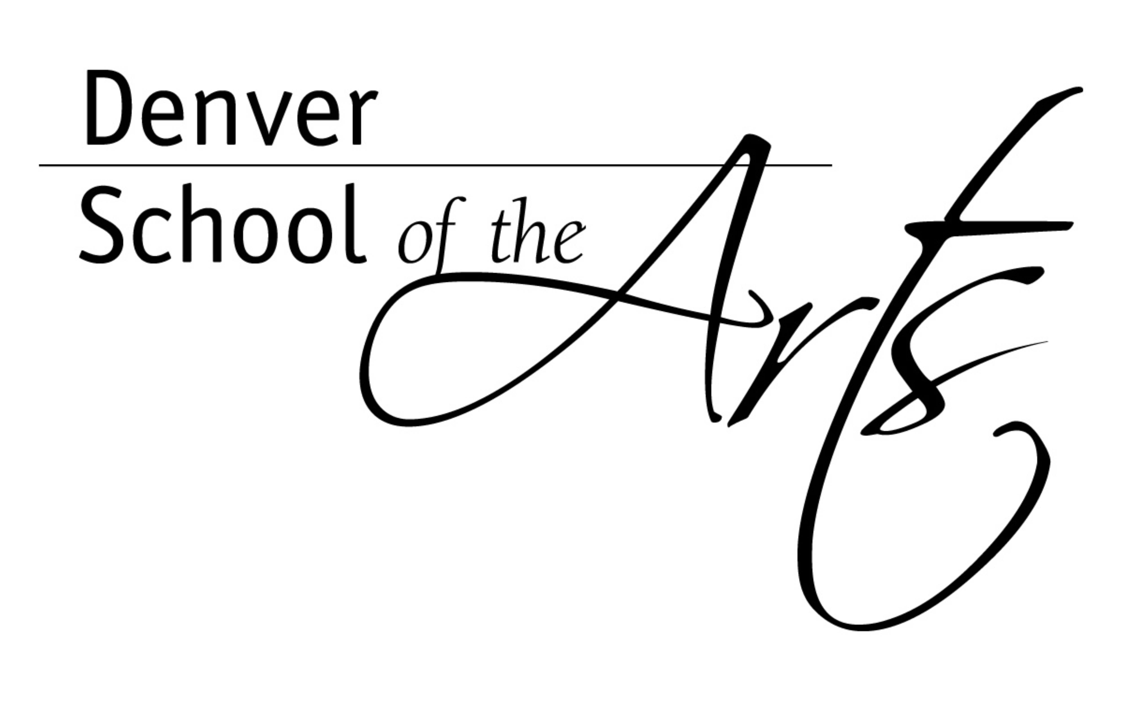DSA ACT Prep for Reading/Writing

During the month of April, three of our high school English teachers will be offering one hour ACT reviews. Each teacher will be covering a different ACT test strategy and/or topic. These ACT reviews will be from 2:45-3:45 on the days they offer their review.

No need to sign up. We encourage each DSA junior to go to each session one time. You will get some different pointers from each DSA staff member.

Writing Basics
Mr. Donnelly
Tuesdays April 2 April 9 April 16
Room B103

This session will go over the ACT Essay Writing Basics. The plan is to look at the 10 key questions of essay writing and discuss strategies to maximize scores. We will then break down the six-point holistic rubric for the ACT writing test followed by reading and grading sample essays.

Sentence Structure Review
Mr. Russell
Wednesdays April 3 April 10 April 17
Room B206

This session will review the basics of sentence structure from parallelism to run-on sentences. Along with review, we will practice on ACT structured questions to help maximize scores on the multiple choice ACT English test.

Punctuation Usage
Mr. Painter
Thursdays April 4 April 11 April 18
Room D213

This session will be reviewing punctuation usage relevant to the ACT test. There are a number of questions that require students to know when to use commas, semicolons, and less commonly used punctuation such as dashes, colons, hyphens and parentheses. Standard usage rules will be covered, and practice questions will be used to get comfortable with the way in which punctuation questions show up on the ACT.

ACT Prebubble – April 17 at 7:35 am
ACT – April 23 at 7:35 am

