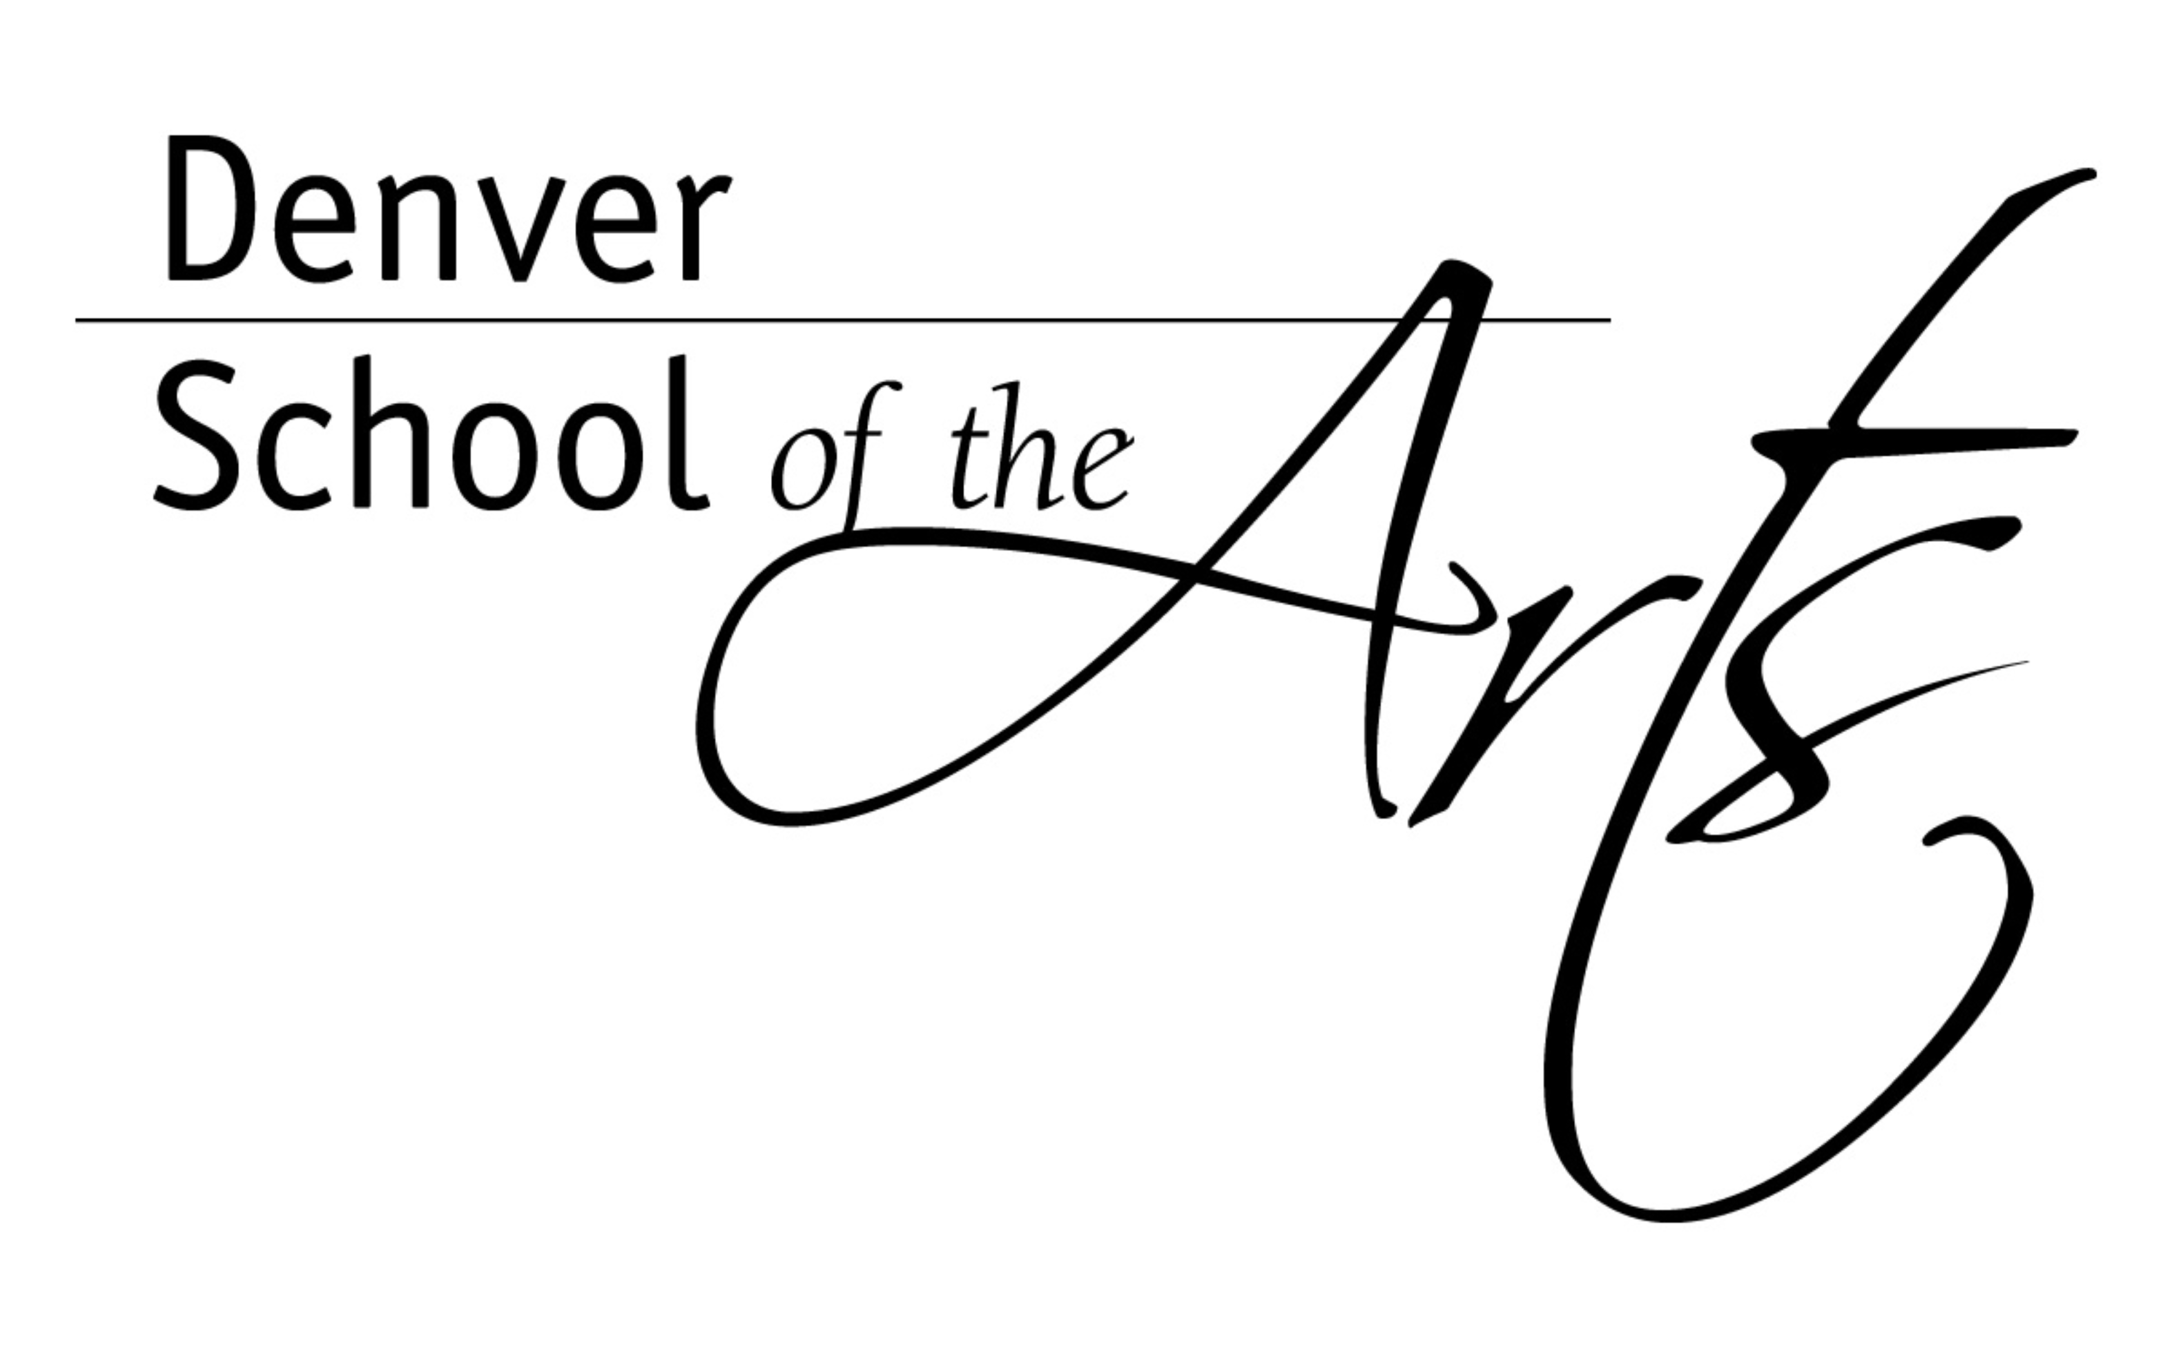
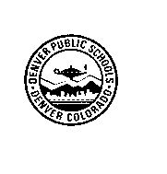
DENVER PUBLIC SCHOOLS
Office of the Principal

Phone(720) 424-1700
Fax(720) 424-1845
http://dsa.dpsk12.org
7111 MONTVIEW BLVD
DENVER, COLORADO 80220

March 27, 2015

Dear DSA Parent/Guardians,

In our continuing effort to provide you with important information, the DSA Administration wants you to be aware of an important assembly/workshop will be occurring for high school students on April 8, 2015 at Denver School of the Arts. These workshops are centered on the cases of sexual assault on college campuses and across the nation that have been widely publicized in the media recently, prompting the creation of the Vice President’s “It’s On Us” program. In reaction to this program’s success, a group of DSA students have been working with administration to create a school environment in which sexual assault is unacceptable and all those impacted are supported. As part of these initiatives, a series of placards will be displayed starting the week of April 6, 2015. While these will be strategically placed for age sensitivity and relevance, it is important to note that this data will be very upfront with information regarding rape, assault, and abuse. We feel these measures are necessary in most effectively educating our students on this topic to create a safer and more inclusive community for our students. If you have any concerns, feel free to contact the DSA administration or Mr. Joe Weber, DSA Social Worker. As a follow up to this important work, we are currently working with Project Pave to present a workshop for parents at a PTSO meeting next fall.

Sincerely,
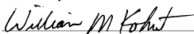
William Kohut
Principal

