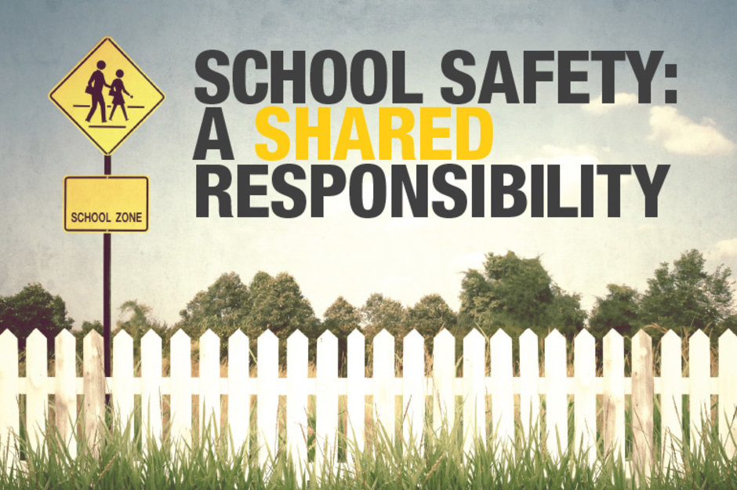  - March 19th  Community Meeting  Department of Safety Presentation  Denver Public Schools Department of Safety would like to invite you to a community meeting for parents. This meeting will address lockdowns, lockouts, shelter-in-place, Safe2Tell, access control policies, situational awareness, traffic safety and much more. Please reserve your spot through the Signup Genius link:  http://www.signupgenius.com/go/60b0f4aadad22abf58-parent  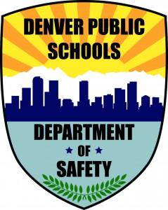 | Emergency Management Resources  ____  Learn what to do when an emergency occurs  ____  Resources available to parents  ____  Visit us at www.safety.dpsk12.org  Teller Elementary  1150 Garfield Street.  720-424-3560  6:00 p.m., March 19, 2018

